Terahertz Spectroscopy Measurements on Black Silicon
by
Jesper Graungaard Bertelsen
AU-ID: au689481, Study-ID: 202204617

Bachelor’s Thesis
in
Electrical Engineering

Supervisor:
Pernille Klarskov

Co-Supervisor:
Rasmus Davidsen

Aarhus University, Department of Electrical and Computer Engineering
<date of submission, e.g. 5 December 2025>

Indholdsfortegnelse
Abstract 4
Introduction 4
Eksperimental setup 4
Verifying the setup 5
Methods and theory 6
Black sillicium 6
Terahertz Time-domain Spectroscopy ( THz-TDS ) 7
The generation ( PCA ) 7
The detection ( PCA ) 8
Possible issues 10
Spectral analyze 12
Usikkerhedsberegninger 13
Experimental results 14
My trial of thoughts 16
Data gathering 16
Removing the reflection by windowing the signal. 19
Describing my signals in terms of refractive indices of the thin film. 21
Uncertainty. 22
Næste skridt? 24
Discussion 24
Future work 24
Conclusions 24
References 24
Bibliografi 25

Opstilling taget fra eksempel:
- Abstract
- Introduction
- Literature Review
- Methodology
- Analysis and Discussion
- Future Work
- Conclusions
- References

Abstract

Introduction

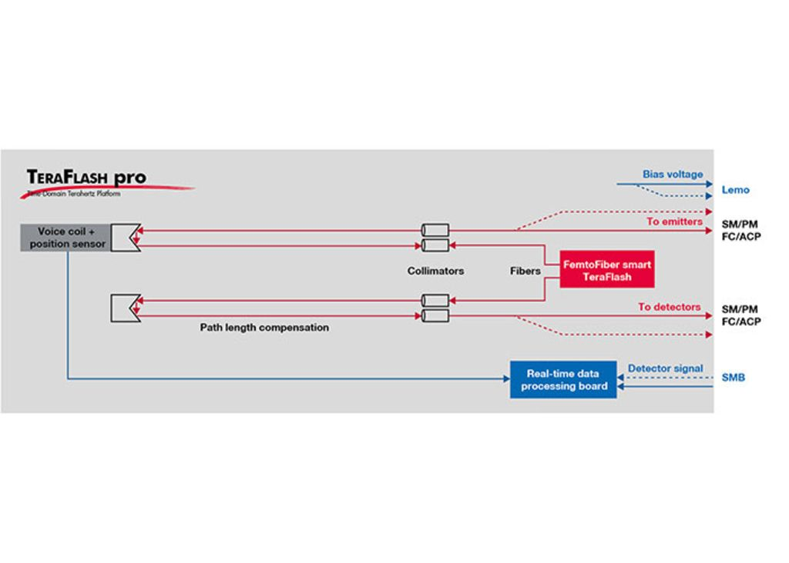
Eksperimental setup
Grej til rådighed, TeraFlash Proen af toptica.
Bord hvor man kan skrue ting fast på. Apperaturer til at holde spejle på plads og ellers justere højden for mediummet.
Grejet fra toptica bruger en FemtoFiber Smart TeraFlash laser,
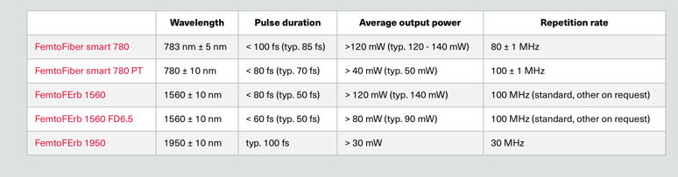
https://www.toptica.com/products/ps-fs-fiber-lasers/femtofiber-smart
På deres hjemmeside har de to kandidater som hedder noget lignende. Time steppet efter sampling afslører, at det er en 0,05ps = 50fs pulse. Dermed er det enten
FemtoFErb 1560 eller FemtoFErb 1560 FD6,5.

Verifying the setup
When having set it all up, we then want to verify, that all is working accordingly. This ensures, that the values I’ll later get can be interpreted correct. For what I’ll be using THz TDS for, it’s to describe etching of the black sillicon reference material. The refractive index of Si is well known and with the depth being known aswell, we should see the refractive index convergerging towards the refractive constant.
Using a change in refractive index of two mediums and taking that in terms of how it affects the change in phase, one can derive an expression for a uniform material to be:
$$n_{si}=\left|∆ϕ\right|·\frac{c}{ω·d}+n_{0} ⋆1$$
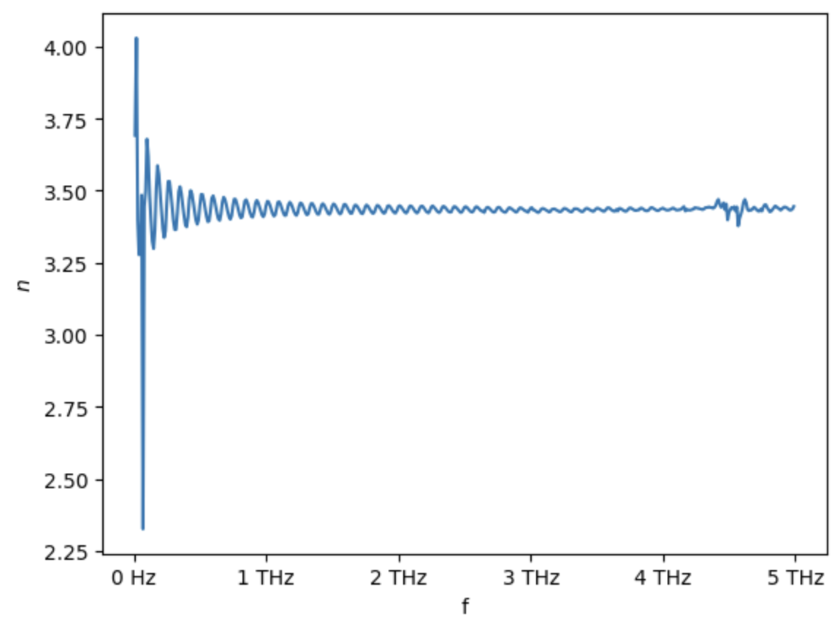
Which we can use for analysis in the frequency domain. [1]
Figure 1: The refractive index of Si varying over frequencies

Due to singularities for $\lim_{ω→0}{n_{si}\left(ω\right)}$ there is methods for overcoming that, making a new refractive index using what’s known as Phase Extrapolation
$$n_{si}^{'}\left(ω\right)=n_{si}\left(ω\right)+m·2π\frac{c}{ωd} ⋆2$$
For m being an arbitrary integer, that ensures, that the best results is seen around $ω=0$. [2]
For my reference sample, $m=0$ made for the best result, meaning that phase extrapolation didn’t help.
Then drawing conclusions from the figure, I saw my refractive index converging towards an approximate of $n_{si}≈3,43$, which are a value of the refractive index one could expect. Having gotten that verification made me able to move on towards new steps.

Methods and theory

Black sillicium
Med dens lave reflektivitet, så er black sillicium et godt materiale når det kommer til at inkapsle solens stråler, som er essencen i en solcelle…
Jeg ved ikke meget om det, men vil give det lidt tid, og prøve at få lidt teori om det indover også.

Terahertz Time-domain Spectroscopy ( THz-TDS )
Hvad? Generalle idé bag.
Hvorfor THz?
”The spectral range between 0.1 THz and 10 THz ( $3,3cm^{-1}-333cm^{-1}$ ) is an important region for low frequency dielectric relaxation and vibrational spectroscopy of liquids, such as water, methanol, ethanol, propanol, and others” [3]. It’s due to properties within molecules and material science and more that motivates us to make analytics in these frequency spectra.
( THz begyndelsen? )
…
It has since been implemented in many field of studies ( Kilde ? ). The TDS stands for Time domain spectroscopy an is a way of analyzing these THz fields by sampling in the time domain. THz - TDS is an optical measurement tool, used within a wide range of academic fields. From the application in medical field, where it has been shown to detect skin cancer, to the field of security and more [4].
Usually one buys these tools premade by companies such as Topica, but within the box a lot is happening. A walk through on the steps within THz TDS will follow.

The generation ( PCA )
For THz generation one can use a more industrial common laser in the fs range. That will give the THz radiation a duration in the ps range, and can have simplifying properties, when it comes to the detection [5] of the THz field. There exist several techniques of creating THz radiation. For my setup, PCA was the chosen one.
PCA stands for photo conductive antenna, and as the name suggest, a photon excites an antenna which makes it more conductive, resulting in a current flow. In THz - TDs the electric field becomes a function taking this current as a variable. In PCA two metal plates are put in parallel to one another. That can be done by lithografically fabricating it on a semiconductor, and biasing it with a bias voltage, that is insufficent for current flowing to. The bias should however be sufficient for the current to flow, when the laser of choice pumps it between the plates. The THz field can then be described as a function of time
$$E_{THz}\left(t\right)∝w_{0}·\frac{\sin\left(α\right)}{r}·\frac{d}{dt_{r}}·\left(I_{PC}\left(t_{r}\right)\right)$$
$α$ is the angle of observation, $w_{0}$ is a diameter of the metal plates and $t_{r}$ is the retarded time, being the time variable time shifted by the time it takes for light to occur at the observer $t_{r}=t-\frac{r}{c}$ [5]. By this relationship we can tell, that the THz field is a function of the change in current across the metal plates. We can also tell, that the THz field is highly divergent by the $\sin\left(α\right)$ faktor, being at min and max values at $±90°$. This is something to take into consideration when setting up the THz - TDS station.
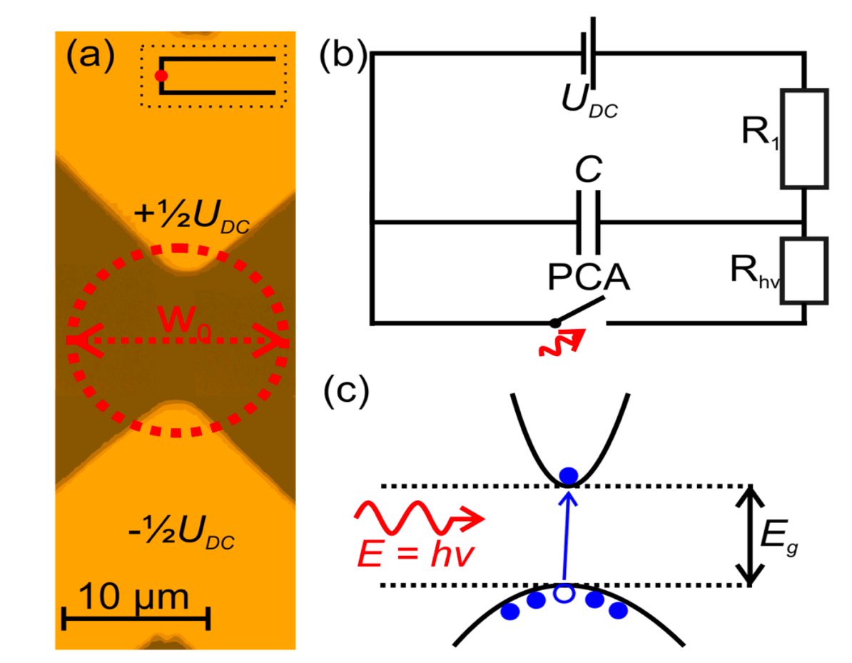

Figure 2: Figure taken from the tutorial of J. Neu and Charles. A. Schmuttenmaer:
(a) Optical microscope image of a dipole photoconductive antenna (PCA). The laser spot is focused in the gap, while a bias voltage is applied between the metallic contacts. Inset: overview of a simplified antenna, the red dashed circle indicates the location of the laser illumination. (b) Simplified electrical circuit diagram illustrating the basic concept of the photoconductive switch. (c) Simplified band scheme illustrating the photoexcitation by a photon with $E=hv>E_{g}$ i.e., larger than the bandgap.

For the case of a femtosecond laser pulse the duration of the THz field will be in the range of picoseconds [5].

The detection ( PCA )
As with the generation of THz fields, the detection has different ways of retrieving the same results as well [6]. In my setup, the equipment uses PCA for the detection.
For the detection of the THz field using PCAs, similar setups to the generation of the THz fields can be used. However instead of biasing the circuit, the emitted THz field at the generation site, should have equal energy as the required energy at the output site [7]. That is, if we’ve succeded in focusing the light, such that everything at the emitter enters the detector. It’s also an assumption, that no loss occurs along the way. A practical design should then take those things into account.

As described in the tutorial of Jens Neu and Charles A. Schmuttenmaer, the femtosecond laser will result in a change of current in the femtosecond range, but the emitted THz field will be in the picosecond range. As the laser within my equipment is also in the femtosecond range, this holds for my setup as well [8].
Issues arives when trying to sample such small time intervals using conventional electronics. Electrical signals has rise and fall times in the regions of nanoseconds. Requiring picoseconds resolution then means, that conventional electronics doesn’t have what it takes to sample useful information. Instead of the electronics having to sample faster than it’s able to, we tend to optics to solve the requirement of picosecond resolution.
At a given time, the signal can be described as:
$$S\left(t\right)∝I_{opt}\left(t\right)·E_{THz}\left(t\right)$$
As conventional detectors are to slow, our solution is then to tend to another relationship:
$$S\left(t_{1}\right)∝I_{opt}\left(t_{1}\right)⋆E_{THz}\left(t\right)$$
Where $E_{THz}\left(t\right)$ comes from the generation side, and the $I_{opt}$ comes from the intensity of the input laser. By convolution we get a relationship towards a message at a given time. Due to the duration of the laser is in fs and the duration of the THz field being in ps, the optical intensity would act as an weighted impulse. If we only care about the proportionality we can say that:
$$S\left(t_{1}\right)∝I_{opt}\left(t_{1}\right)⋆E_{THz}\left(t\right)≈δ\left(t_{1}\right)⋆E_{THz}\left(t\right)$$
$$S\left(t_{1}\right)∝E_{THz}\left(t_{1}\right)$$
That gives us a relationship, that we can use for sampling [8].

At a set time $t_{1}$, we will get the information corresponding to the electric field at $t_{1}$. A timeshift of the input laser can then result in information about different points on the electric field.
As
$$s=t·c$$
For s being the path length, c the speed of light, we have a relationship between distance required as a function of time resolution required.
For a laser in the femtosecond region resulting in picosecond THz radiations, the lengths required to achieve those resolutions are in the millimeter range. That makes it sensible to small ranges, and computer-controlled position stages can be used to fulfill those requirements. [8]

Possible issues
As our THz field will be in the range of picoamperes to nanoamperes, noise becomes a crucial issue. Our noise levels can be modelled by the Johnson-Nyquist Noise and can be evaluated to be about the mid nanoampere spectrum. That means that filtering becomes an essential part in the selection between what’s noise and what’s information [7].
Before heading towards any solution, the full impact must be taken into account. We do have to digitalize our information as well to make it more accessible, and sampling has a huge impact on the signal as well.
How one might have overcome these challenges differs from whom have solved it. For my setup, Toptica hasn’t made it known how, and might be the same for other companies aswell.
However one technique of sampling is Sample and Hold, which may or may not have been used within the equipment of ours.
Sample and Hold takes one value and samples that of a given signal. The value it takes can be configured differently, but some common ones are: The value seen at sampling start and the value averaged throughout the duration of the sampling.
The averaged interval could lead to some benefits or drawbacks, depending on how one looks at it. Mathematically it could be represented by:
$$S\left[n\right]=\frac{1}{T}·\int_{n·T}^{\left(n+1\right)·T}{E_{THz}\left(t\right)}dt$$
If I were able to right it as a convolution, I could describe how the response function changes the THz field doing sampling.
$$y\left(t\right)=E_{THz}\left(t\right)⋆h\left(t\right)=\int_{-∞}^{∞}{E_{Thz}\left(τ\right)}h\left(t-τ\right)dτ$$
Say
$$h\left(t\right)=\left\{\begin{aligned}\frac{1}{T}, 0≤t<T \\ 0, else\end{aligned}\right\}$$
The integral will only occur when
$$0≤t-τ<T \\ -t≤-τ<T-t \\ t≥τ>t-T$$
And my function is constant in the interval with a value of $\frac{1}{T}$
$$y\left(t\right)=\frac{1}{T}\int_{t-T}^{t}{E_{Thz}\left(τ\right)}dτ$$
If this is my time function, and my sampled signal should be a construction of that function, then
$$S\left[n\right]=y\left(?\right)=\frac{1}{T}·\int_{n·T}^{\left(n+1\right)·T}{E_{THz}\left(t\right)}dt$$
Sampling at $\left(n+1\right)T$ should give that result.
$$S\left[n\right]=y\left(\left(n+1\right)T\right)=\frac{1}{T}\int_{\left(n+1\right)T-T}^{\left(n+1\right)T}{E_{Thz}\left(τ\right)}dτ=\frac{1}{T}\int_{nT}^{\left(n+1\right)T}{E_{Thz}\left(τ\right)}dτ$$
But $\left(n+1\right)$ seems like a anticausal setup, which it is. In reality, the sampling doesn’t predict future value, but this is just a way to analyze a function trying to show what’s happening by averaging periods of the sample and hold.
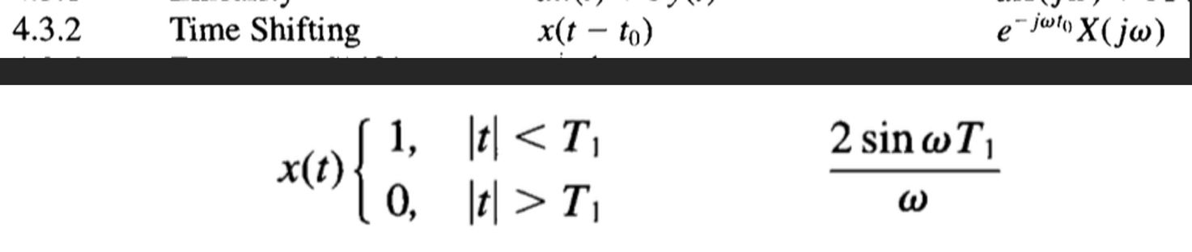
$h\left(t\right)=rect\left(\frac{t-\frac{T}{2}}{T}\right)=\frac{1}{T}, 0≤t<T$
Figure 3: Frequency properties and transformation of time domain signals
$$h\left(t\right)→^{F}H\left(jω\right)=e^{-\frac{jωT}{2}}·\frac{2\sin\left(ω·\frac{T}{2}\right)}{ω} CITATION ALA96 \backslash l 1030 [9]$$
Sinc kan beskrives i forhold til grader eller ej, $sinc\left(x\right)=\frac{\sin\left(x\right)}{x}$ er en af dens beskrivelser.
$$H\left(jω\right)=e^{-\frac{jωT}{2}}·2·\frac{\frac{T}{2}}{\frac{T}{2}}\frac{\sin\left(ω·\frac{T}{2}\right)}{ω}=e^{-\frac{jωT}{2}}·T·\frac{\sin\left(ω·\frac{T}{2}\right)}{ω·\frac{T}{2}} \\ H\left(jω\right)=e^{-\frac{jωT}{2}}·Tsinc\left(\frac{ωT}{2}\right)$$
Som har et fase og en gain led.
$\left|H\left(jω\right)\right|=Tsinc\left(\frac{ωT}{2}\right), ∠H\left(jω\right)=e^{-\frac{jωT}{2}}$
Så eftersom at mit Sample og Hold virker som en weighted average, så vil dens betydning på mit samplede signal være, at min samplede signal bliver ganget med en sinc funktion omkring DC frekvens. Samtidig kender jeg også noget til hvordan dens fase ændrer sig.
Det vil altså sige, at min Sample og Hold agerer lavpass, og det kan både være en hindring og eller en løsning på noget andet.
…

Snak om hvordan vi tilpasser frekvenserne lavpass karakteristikken, og hvordan det måske kan hjælpe os af med støjen fra detektoren.

Spectral analyze
Why 0.8; 1.15 THz?
$d≪λ$ assumption? Lines
0,8THz er valgt af Yasith pga, stabilitet. $λ_{min}=260,9μm=>f_{max}=1,15THz$ og $d_{film}≪λ_{min}$, så jeg kunne egentlig have valgt en vilkårlig bølgelængde højere end det. Men som sagt, 0,8THz er taget pga. stabilitet.

Hvorfor? ( Motivation, Egenskaber & fordele )
Hvordan?
- Generering?
- Detector side?
- Sampling? Optisk tids resolution.
- Problemer? Water vapor
- Signal behandling? Vindue

Hvorfor ikke? ( Ulemper, dyrt og ikke industriklart? )

Usikkerhedsberegninger
Da det kan være meget svært at udlede et udtryk, hvor man simpelt kan sige, at går dette udtryk mod A, så vil mit udtryk gå mod min/max, så gik jeg videre til at bruteforce beregninger.
Operationerne
Til operationerne varierer jeg først på (dref, dsam, dfilm) til indekserne (j, k, i). Dernæst varierer jeg for alle de scans som jeg gjorde til hvert type, M = 5, med indeks m.
$avg\left\{n_{f, j, k, i}\right\}$ <- Spektret fra [0,8THz; 1,15THz]. Avg. medføre en skalar
$n_{f max}=\max_{m}{\max_{j}{\max_{k}{\max_{i}{avg\left\{n_{f, j, k, i, m}\right\}}}}}$ <- Upper bound.
$n_{f mean}=\underset{m}{avg}{\underset{j}{avg}{\underset{k}{avg}{\underset{i}{avg}{avg\left\{n_{f, j, k, i, m}\right\}}}}}$ <- Mean value.
$n_{f min}=\min_{m}{\min_{j}{\min_{k}{\min_{i}{avg\left\{n_{f, j, k, i, m}\right\}}}}}$ <- Lower bound.
Og det samme for volume fraction
${volFrac}_{ max}=\max_{m}{\max_{j}{\max_{k}{\max_{i}{avg\left\{{volFrac}_{j, k, i, m}\right\}}}}}$ <- Upper bound.
${volFrac}_{mean}=\underset{m}{avg}{\underset{j}{avg}{\underset{k}{avg}{\underset{i}{avg}{avg\left\{{volFrac}_{j, k, i, m}\right\}}}}}$ <- Mean value.
${volFrac}_{min}=\min_{m}{\min_{j}{\min_{k}{\min_{i}{avg\left\{{volFrac}_{j, k, i, m}\right\}}}}}$ <- Lower bound

Experimental results
Instead of the uniformly distributed Si wafers, these types were now the result of etching the reference substances, for them to have a layer of both air and Si.

The expression used in the verifying of the setup assumed uniform samples. What I then need is an equation, that takes this new structure into account.
Using the assumption that the incident beam has $d≪λ$ and the incident angle is estimated by small angle approximation $\sin\left(δ\right)≈δ, \cos\left(δ\right)≈1$, an expression of such has been derived:
$$n_{f}=\sqrt{\frac{T·\left(1+n_{s}-n_{s}·\frac{iωd}{c}\right)-\left(n_{s}+1\right)·e^{iδ_{2}}}{T·\frac{iωd}{c}}}$$
For $δ_{2}=\frac{ωn_{s}}{c}·\left(p_{sam}-p_{ref}\right)$. $n_{s}$ is the refraktive index of the substrate, T is the transmission function, d is the depth of the film, $p_{sam} \& p_{ref}$ are the thicknesses of the sample and reference respectively, and c is the speed of light [10].

Trying to evaluate previous finds, using previous values have been difficult. Troughout trial an error a lot of problems have been solved to try to find the right solutions. One path took me down varying the dimensions. The wafers are assumed to be of one shape, but by such small scales, the incorrect handling can damage it for later use. Furthermore, the uniform wafers are fabricated with an uncertainty of $± 20μm$, which is significant given that it’s only about $500μm$, making the uncertainty of uniform wafers be $4\%$.

These wafers has been tested previously, so by default, verifying previous findings, should be the first thing to show.
What’s previously been found.

Figure 4: Figures taken from previous findings using the same wafers. "Figure 6. (a) SEM cross section image of the reference wafer (red arrow indicates the substrate thickness from top"

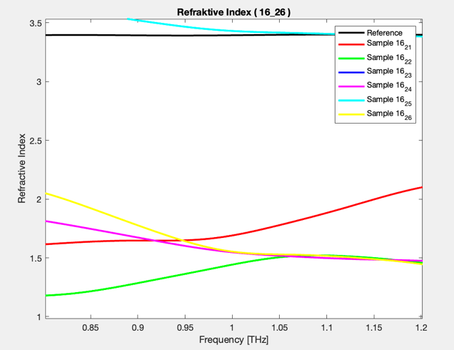
My results with his data:
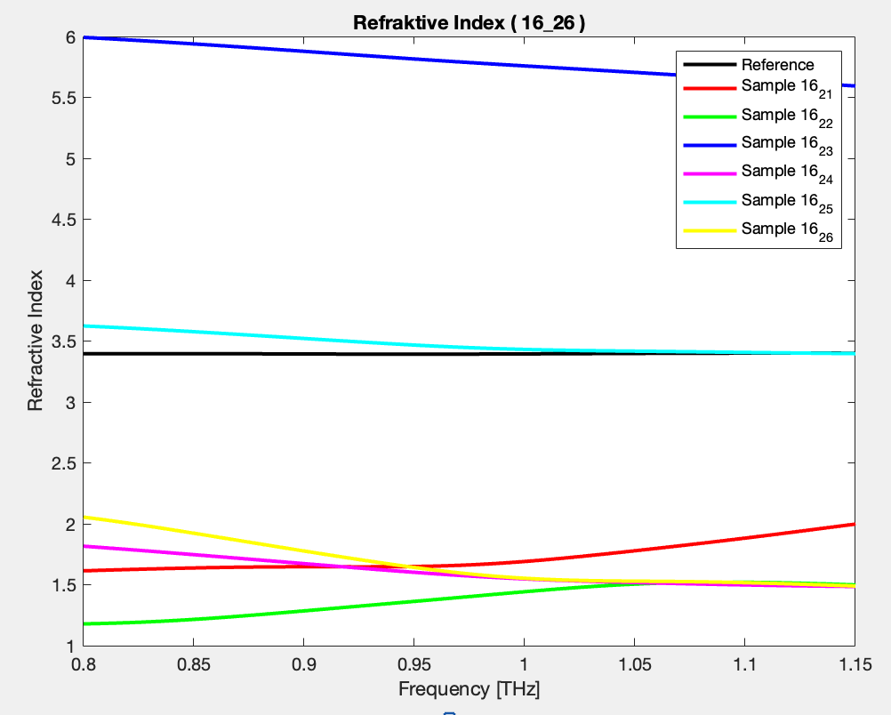
Using his dataset I was able to get similar results for type 16_22, 16_24, 16_26.
Some of them were off, but neglecting that for now, some of it worked, and so I could begin trying to use my own dataset.

My trial of thoughts
To differ from the one of Yasith, who had fine tuned data, the idea of my approach was to describe the samples overall. Not at a fine location, that has been unharmed, but something, that should be indicate the right sample even with slightly worn wafers.
The idea was simple. Given a sample, take M number of datasets of it. With more data, the more averaging the model of the sample would be.

Data gathering
I could go about sampling in several distinct ways, I chose to try to model a gradient image of the wafer. I had 6 types of wafers of a half circle figure. I chose to sample from the tip of it to the center. It were a bit more than 2cm in radius, which gave me [2, 1.5, 1, 0.5, 0] as my sampling interval for each type. Using tools, I then set my THz TDs to just transmit through the top of my wafer, and precisely adjusting the heights by the intervals.
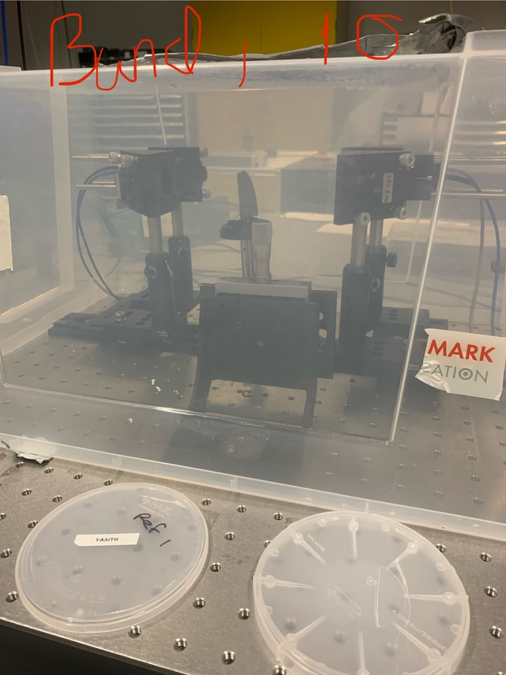
Given this approach, our thesis is, that the samples going towards the center would lead to our signal being further and further time shifted. We say this, as etching the wafers is said to not uniformly transform the wafer, but does etch more the close it is to the edge.
Figure 5: My setup
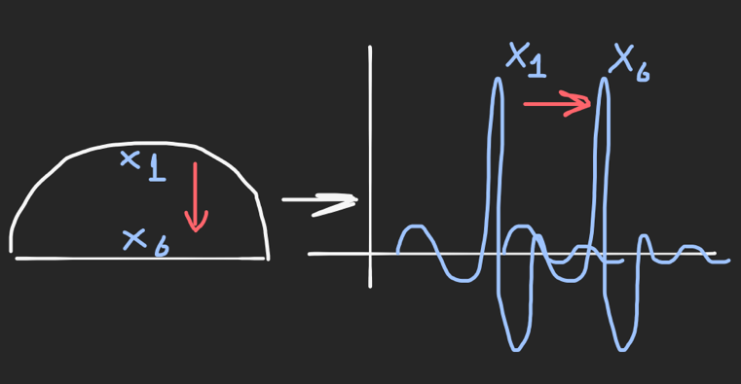
Figure 6: The thesis
It sampled. Due to second and third transmissions, having reflected within the material, I will first show the full signal, and then zoom in on what my samples tells me. Moreover I will plot my some data of just air, and the reference wafer, which every wafer should have been etched from. The thesis for that is, that the air arrives earliest, as the light propagates the fastest in air. Then second fastest through my etched wafers, as they have less material to propagate through.

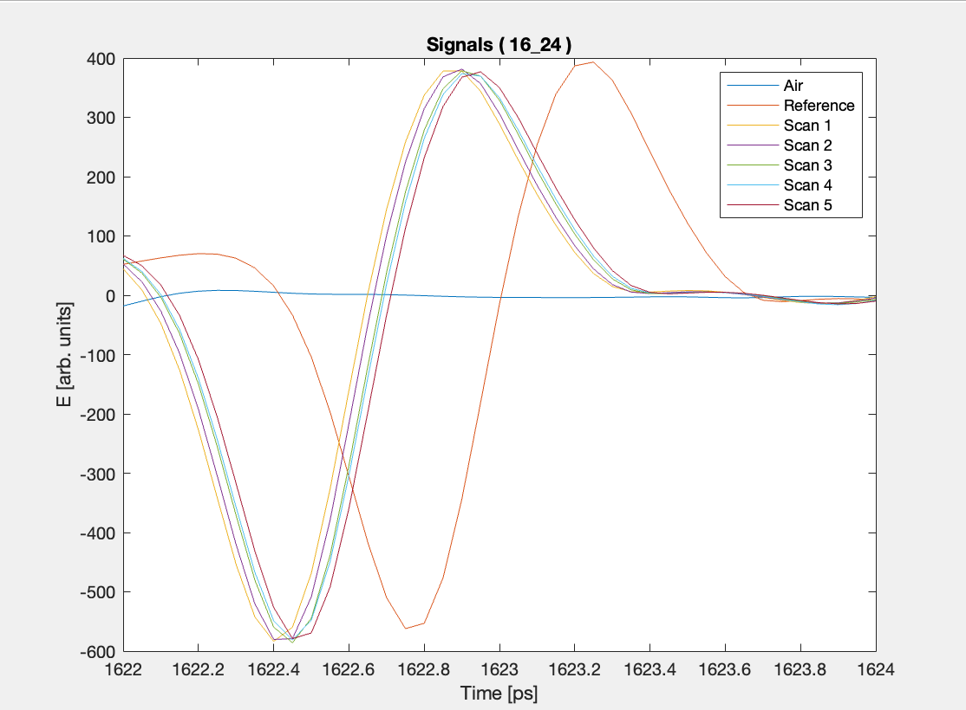
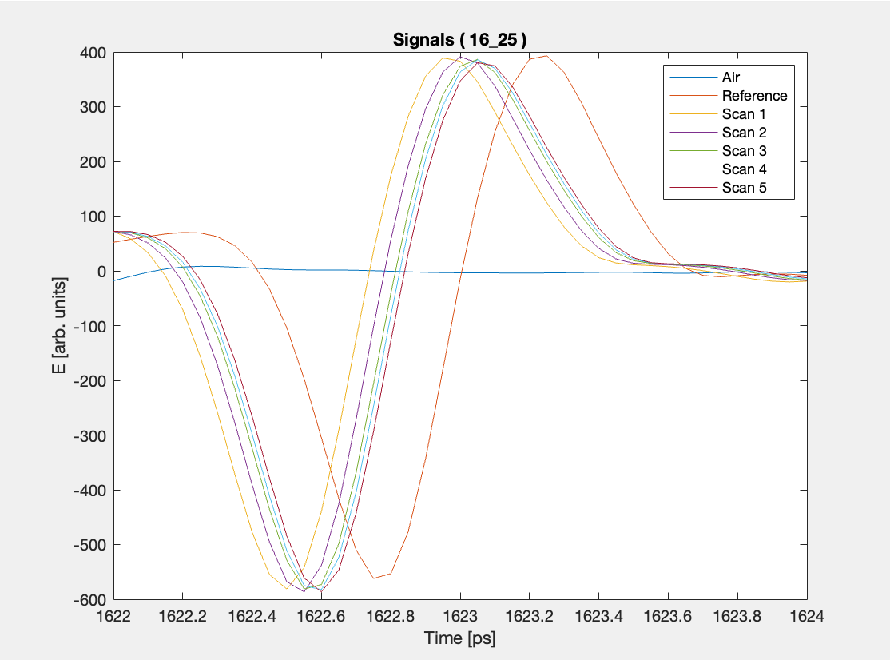
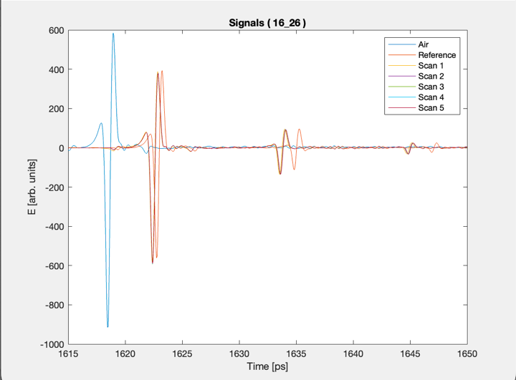
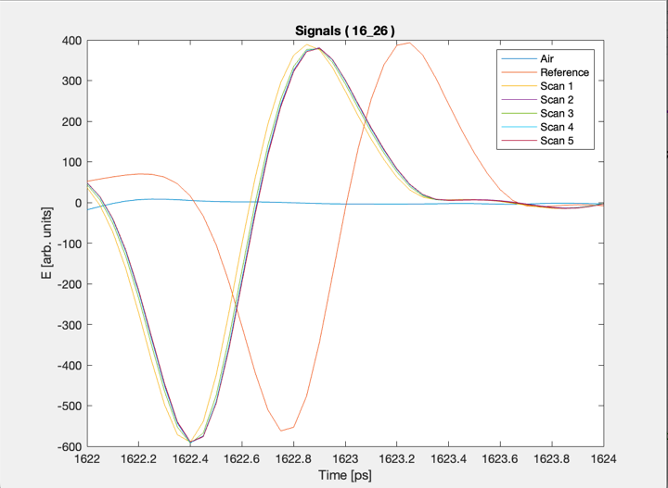
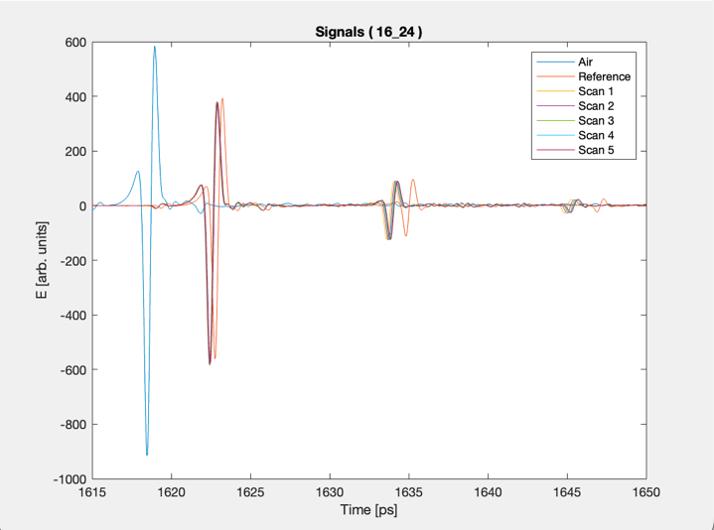
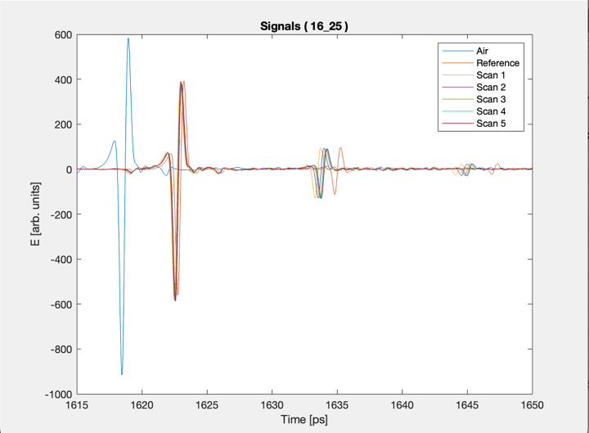

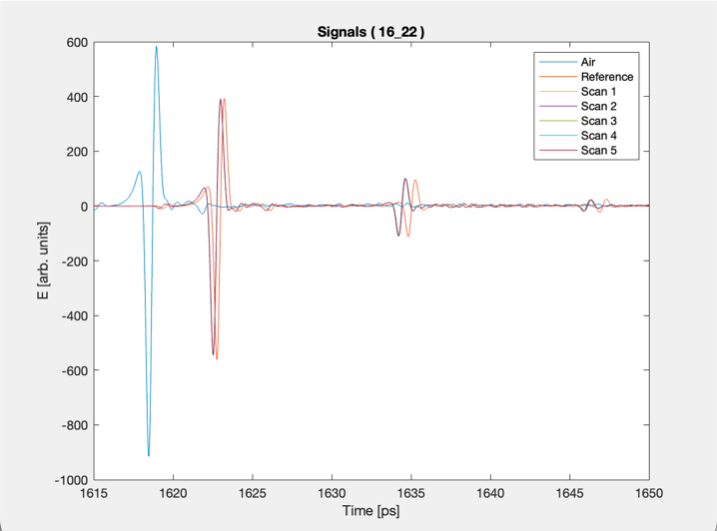
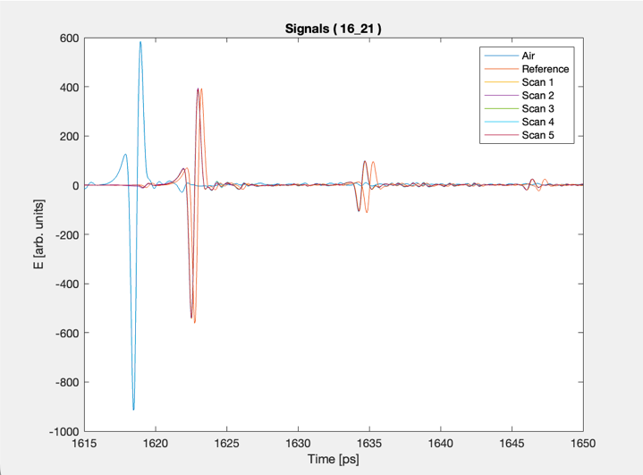
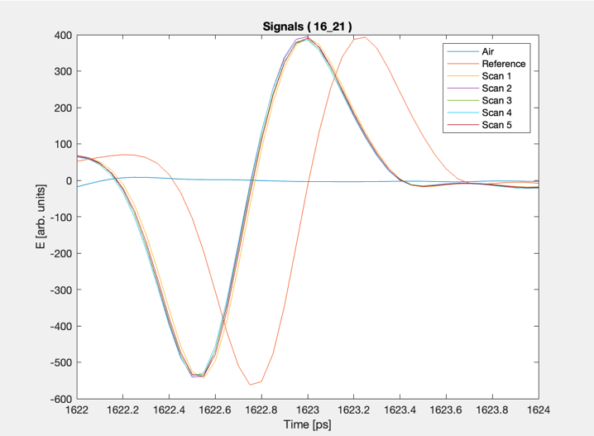
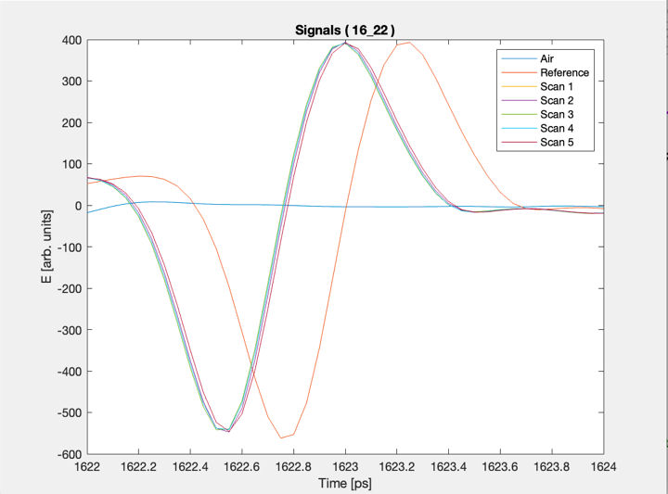
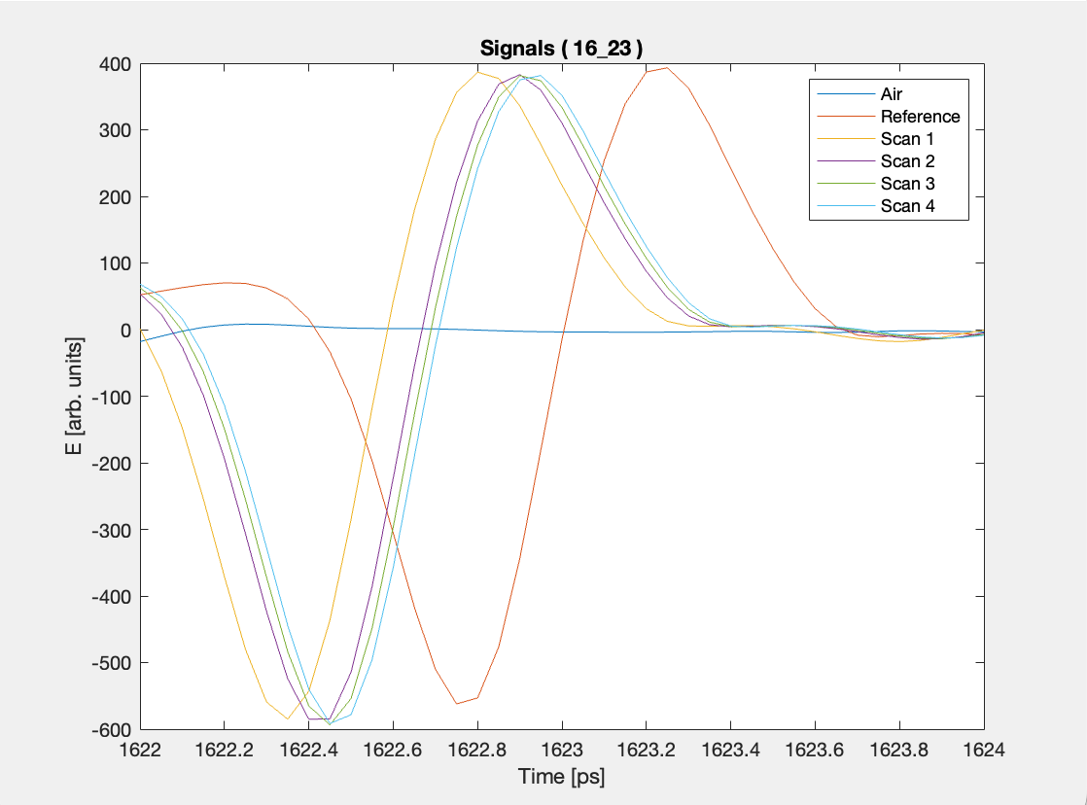
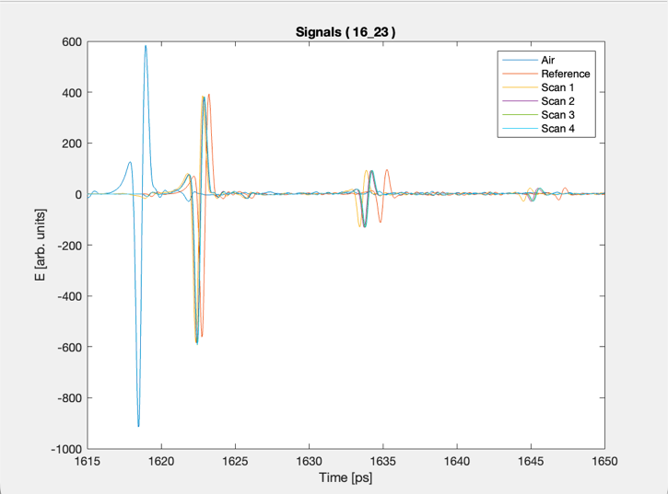
* Things to note from these plots. For type 16_23 I forgot one scan and that’s why there’s only 4 scans. Another note is, it seems that I’ve sampled correctly. Every scan seems to be going towards the reference signal made from the uniform sillicon, except for 16_22 and 16_21, where there doesn’t seem to be that huge of difference, and the minor difference is random. For all it holds, that the air beam was the first as well.

Removing the reflection by windowing the signal.
Focusing on the data of choice my choice of windowing is to pick out the datapoints I want. This is equivalent to a square window but with the leading and trailing zeros removed. This has an effect on the frequency data, which now doesn’t see the time shift, as it had originally.
Let’s check the effects of it:
My window is from $n_{i}=\left[117;307\right]$
In my original signal that would have stood for
$x\left[n-n_{0}\right]→^{F}e^{-jωn_{0}}X\left(e^{jω}\right)$ [11]
Let me keep that in mind. An original square window:
$w\left[n\right]=\left\{\begin{aligned}1, 0≤n<N \\ 0, else \end{aligned}\right\}=rect\left(\frac{n-\frac{N}{2}}{N}\right)$
$w\left[n\right]→^{F}e^{-jω·\frac{N}{2}}·\frac{\sin\left(ω·\left(\frac{N}{2}+\frac{1}{2}\right)\right)}{\sin\left(\frac{ω}{2}\right)}$ [12]
Keeping in mind, that what I got rid of was $e^{-jω·117}$, that’s equivalent to multiplication by $e^{jω·117}$. And that $N=307-117=190$
My final windowing effect would then be.
$w\left[n\right]→^{F}e^{jω·117}e^{-jω·\frac{190}{2}}·\frac{\sin\left(ω·\left(95+\frac{1}{2}\right)\right)}{\sin\left(\frac{ω}{2}\right)}$
$w\left[n\right]→^{F}e^{jω·\frac{44}{2}}·\frac{\sin\left(95,5·ω\right)}{\sin\left(\frac{ω}{2}\right)}$
So my window will contribute by
$\left|W\left(e^{jω}\right)\right|=\frac{\sin\left(95,5·ω\right)}{\sin\left(\frac{ω}{2}\right)}, ∠W\left(e^{jω}\right)=e^{jω·\frac{44}{2}}$
In the frequency domain.

But why 117?
My decision towards this interval, was due to the consistency of what Yasith did. His data started being sampled at a different time, but where he’s cropped his signal from, is n = 117 on my dataset.

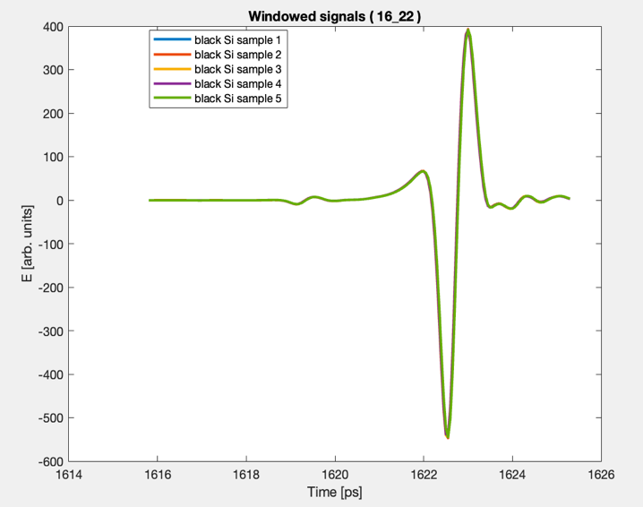
Looking at my windowed signals.
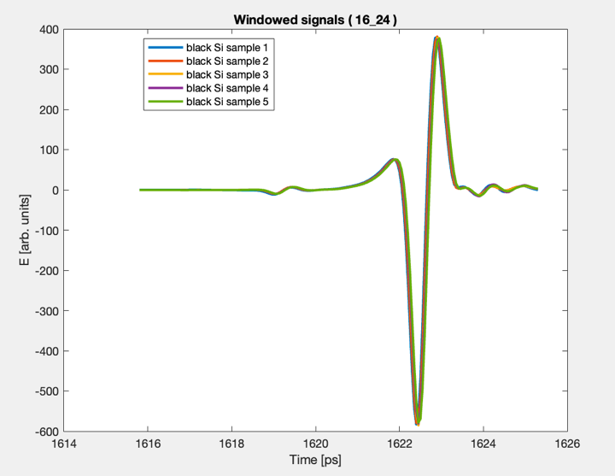
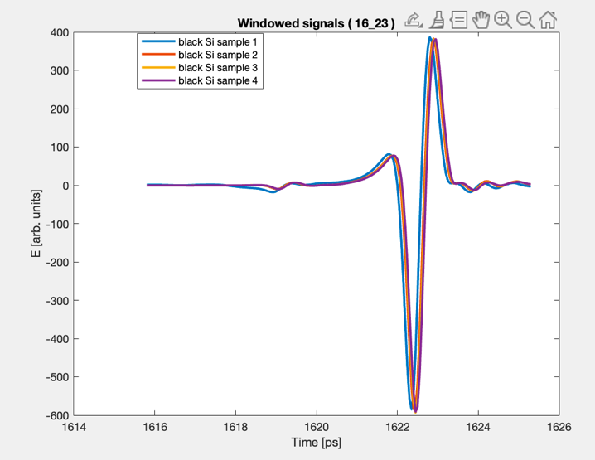
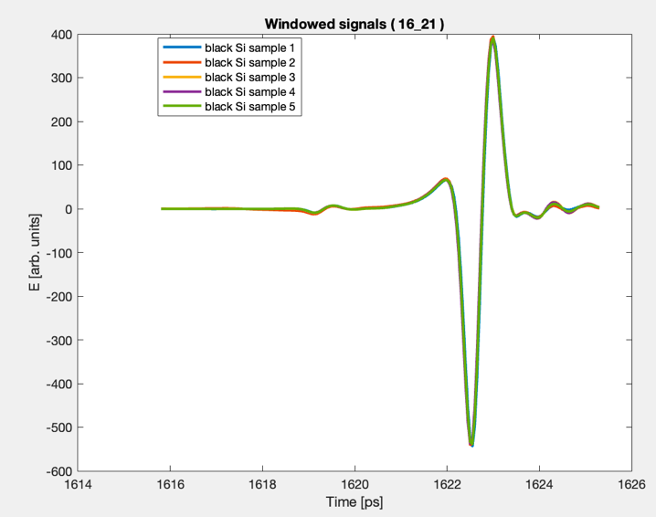
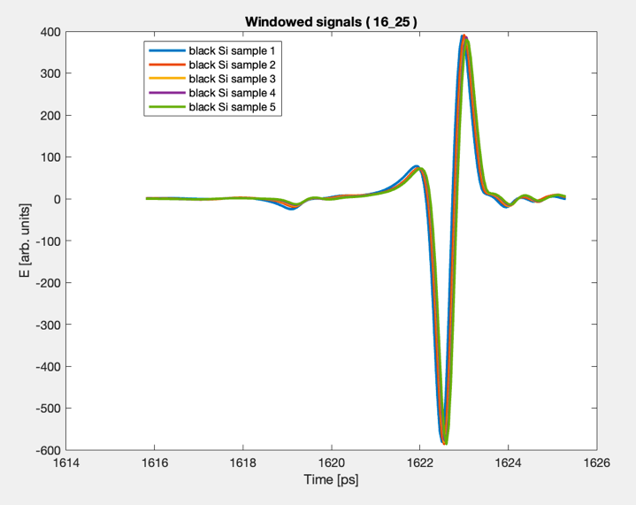
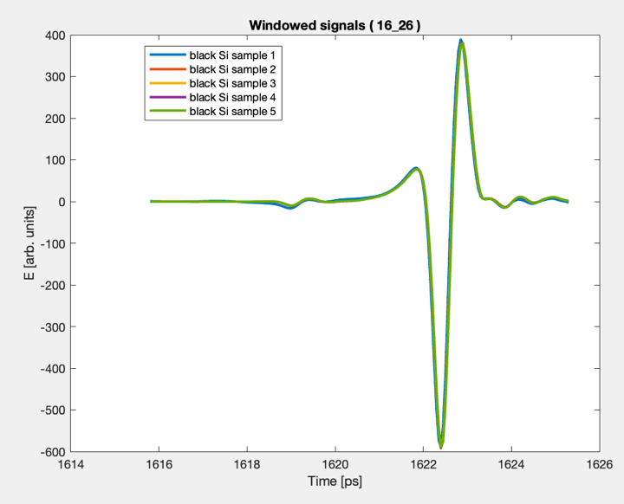

Describing my signals in terms of refractive indices of the thin film.
Making use of FFT to transform my sampled data and my reference data, both in time domain, into frequency domain.
$E_{THz}\left(t\right)→^{FFT}E_{THz}\left(ω\right)$
$T{\left(ω\right)}^{\left(I\right)}=\frac{E_{sample}^{\left(I\right)}}{E_{ref}^{\left(I\right)}}$ [10]
The $\left(I\right)$ just denoting the first incident beam.
This transfer function is what will be used within the thin film formular.
The equation previously shown for verifying Yasiths results:
$n_{f}=\sqrt{\frac{T·\left(1+n_{s}-n_{s}·\frac{iωd}{c}\right)-\left(n_{s}+1\right)·e^{iδ_{2}}}{T·\frac{iωd}{c}}}$ [10]
The results of my data:
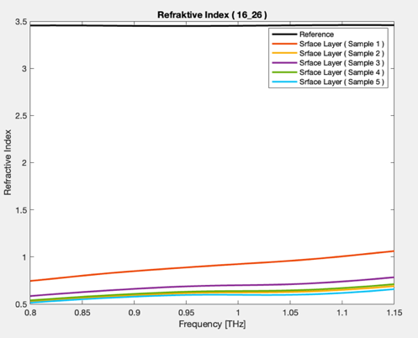
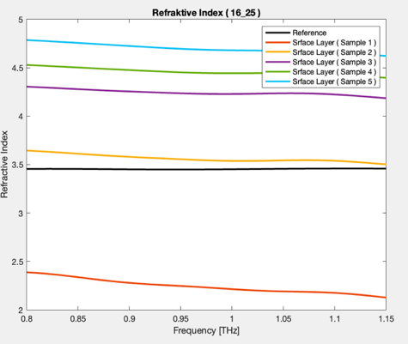
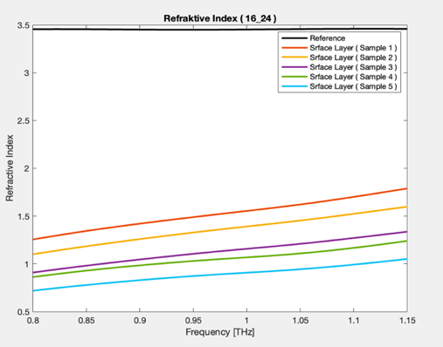
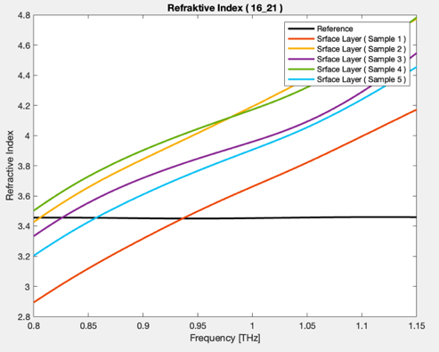
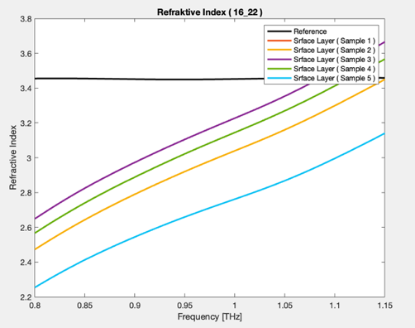
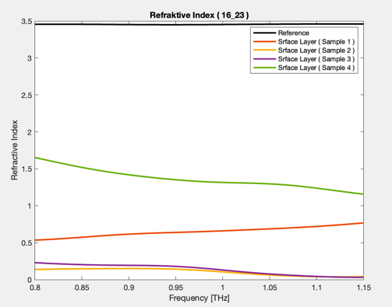
Mine resultater med mine værdier
Things to note here is, that the black bar represents my reference. The refractive indices of my etched wafers can not surpass this in reality. The refractive indices should neither be able to fall less than the refractive index of air, $n_{air}=1$.
The refractive index is therefore bound by reality to be
$$n_{f}∈\left[1;3.43\right]$$
This isn’t the case for a lot of my samples. Their results given my information isn’t valid then. But if the assumptions that I made along the way isn’t correct, my results shouldn’t be either.

Uncertainty.
Verifying the same results of Yasith, given my sampled data. My Type 16_23 scan 4, as well as my type 16_25 scan 1 looks like they are about where he sampled his data from. But other than that, my results differ or looks unreal.
That’s when I started doubting our assumptions about the dimensions of the wafers. Within the thin film equation we use 3 different measures. $d_{ref}, d_{sam}, d$.
From fabrication, of uniform silicon wafers, I can only assure, that the wafers are about $500μm±20μm$ and the thin films are estimated from images and are in the order of single digit $μm$. I made a fair assumption about the uncertainty of those being about $±0,5μm$.
$$d_{ref}, d_{sam}±20μm$$
$$d±0,5μm$$
I tried to express the equations in terms of min max values. Due to the higher dimensionality of variables, I didn’t find any suitable expression in terms of that.
Instead, I calculated for multiple variations of the dimensions, and took the min max values.
For type 16_26 I found that:
$$d_{max}=d\left(5, 1, 1\right)=\left[543,92;481,2;5\right]μm \\ d_{min}=d\left(2, 1, 5\right)=\left[513,92;481,2;6\right]μm$$
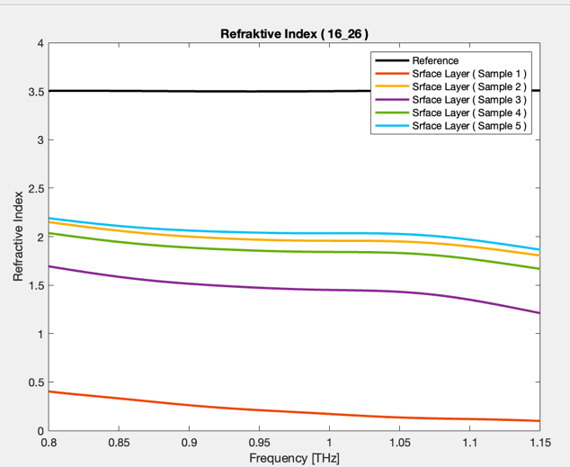
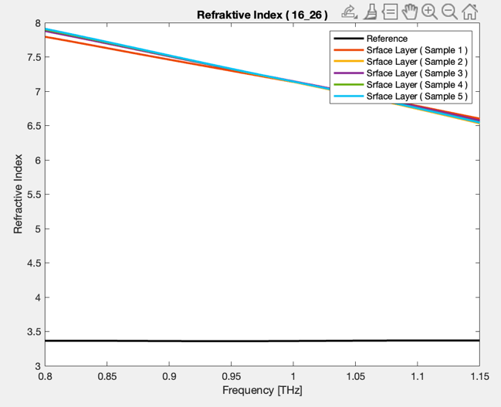
Would result in:
Max Min

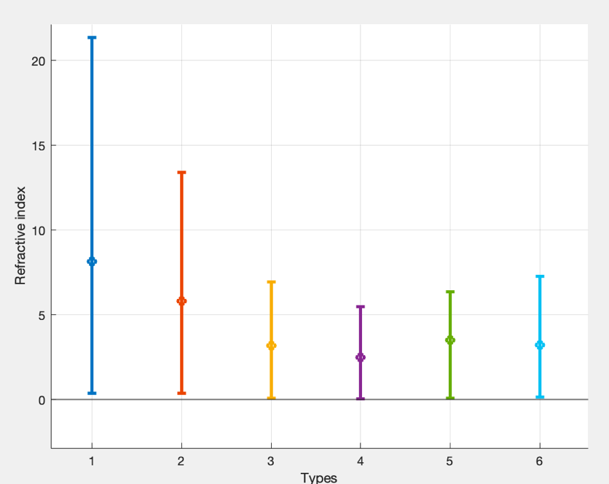
And that lead me to trying to find the min max of every type in terms of the scans.

….
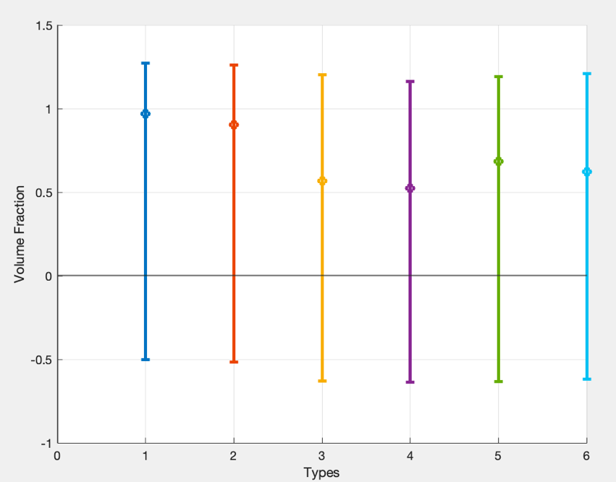
Volume fraction

Næste skridt?
- Min max plots til at forklare for hver type, for at forklare hvorfor jeg gør hvad jeg gør.
- Lave en grænseværdi? Forkaste værdier som er over det refraktative indeks for silicium?
  - Normalfordeling eller ej? Giver kun mening, hvis der er en del af tage af.
- Er min reference uniform? Kan jeg stirre mig blindt på, at det kun er ved etchingen af waferen, at der kommer en variation? Eller er der allerede en variation til start? ( Testede det i session 27 )
- Normal fordeling?

Discussion

Future work

Conclusions

References
https://www.toptica.com/products/terahertz-systems/time-domain/teraflash-pro?gad_source=1&gad_campaignid=11174164687&gbraid=0AAAAACcXkr4qej04YU3L2IcDEkUEAKXEg&gclid=Cj0KCQiAxJXJBhD_ARIsAH_JGjhTIgyeGvxpCblPZhtStP0b_JkqpdiC-K26FiAEXBBShBT-Nh_CbYQaAqNuEALw_wcB#gallery-1
https://www.youtube.com/watch?v=X7vrvQcmy8c

Bibliografi

[1] | L. Madsen, »3.2 Refractive index by phase shift,« Terahertz Time Domain Spectroscopy for characterizing thin films, 3 June 2001.
[2] | P. U. Jepsen, »2 THz-TDS Phase Retrieval,« Phase Retrieval in Terahertz Time-Domain Measurements: A "how to" Tutorial, pp. 400-401, 27 Marts 2019.
[3] | C. A. S. Jens Neu, »I. Introduction,« Tutorial: An introduction to terahertz time domain spectroscopy (THz-TDS), p. 1, 9 July 2018.
[4] | C. A. S. Jens Neu, »I. INTRODUCTION,« Tutorial: An introduction to terahertz time domain spectroscopy (THz-TDS), p. 1.
[5] | C. A. S. Jens Neu, »B. THz generation from a PCA,« Tutorial: An introduction to terahertz time domain spectroscopy (THz-TDS), pp. Side 3-4, 17 December 2018.
[6] | C. A. S. Jens Neu, »IV. THz DETECTION,« Tutorial: An introduction to terahertz time domain spectroscopy (THz-TDS), pp. 4-5, 9 July 2018.
[7] | C. A. S. Jens Neu, »B. THz detection with PCAs,« Tutorial: An introduction to terahertz time domain spectroscopy (THz-TDS), p. Side 5, 17 December 2018.
[8] | C. A. S. Jens Neu, »II. CONCEPT OF TIME-DOMAIN SPECTROSCOPY (TDS),« Tutorial: An introduction to terahertz time domain spectroscopy ( THz - TDS ), p. Page 2, 17 December 2018.
[9] | A. S. W. S. H. N. Alan V. Oppenheim, »4.6 Tables of Fourier properties and basic Fourier transform pairs,« Signals & Systems, 2nd edition, pp. 329 - 330, 1996.
[10] | L. Madsen, »5.2 Substrate thickness variation,« Terahertz Time-Domain Spectroscopy for characterizing thin films, pp. 54-55, 3 June 2021.
[11] | A. S. W. S. H. N. Alan V. Oppenheim, »TABLE 5.1 PROPERTIES OF THE DISCRETE-TIME FOURIER TRANSFORM,« Signals and Systems, 2nd edition, p. 391, 1996.
[12] | A. S. W. S. H. N. Alan V. Oppenheim, »TABLE 5.2 BASIC DISCRETE-TIME FOURIER TRANSFORM PAIRS,« Signals and Systems, 2nd edition, p. 392, 1996.
[13] | »II. Concept of Time domain spectroscopy ( TDS )«.

